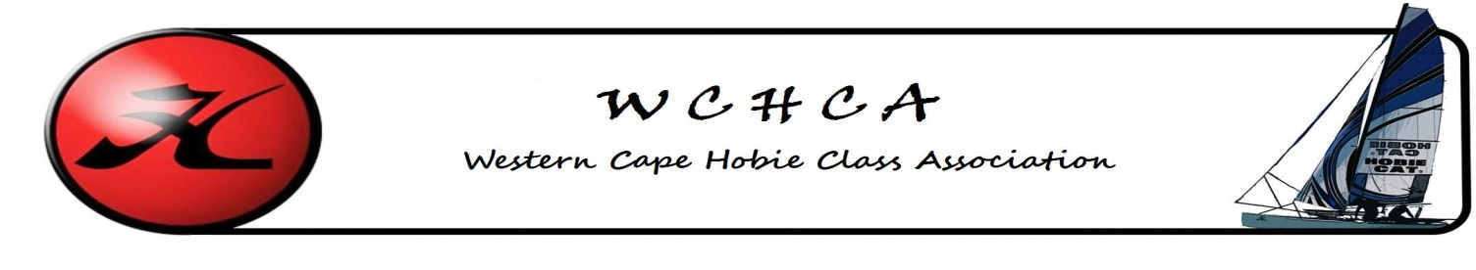
W.C. Hobie Class Association
Membership Form 2017
First Name
Surname
Date of Birth
Email
Cell Phone
Land line
Fax Number
Address
SAS No.
Club
Hobies Owned | Hobie 14 |  | Hobie 18
 | Hobie 16 |  | Tiger
 | Dragoon |  | Youth
WCHCA - Class fees - proof of payment to jryall@southey.co.za
Membership is valid from January to December
Category | Fee |  | Paid
Sailor | R 400.00
Sailor + any No. of Crew | R 600.00
Under 25 | R 200.00
Associate Member | R 135.00
 | Banking Details
 | Account in the name of: |  | WCHCA
 | Bank |  | ABSA – Savings A/c
 | Branch Code |  | 632 005
 | Account No. |  | 9254296256
 | Beneficiary Ref: |  | Your Name & Surname

Amount Paid______________________ Payment Method_______________ Date_________________________

